This is a link to the [original document](https://magoosh.com/hs/ap-calculus/2017/ap-calculus-review-disk-washer-methods/)

Disk Method

* Use this method when you are given an axis of rotation and a function only
* This will create a solid shape that can then be divided into small disks, hence the name
* 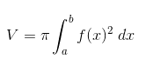
* This only takes into account one formula
* Example problem:

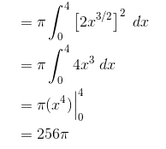

Washer Method

* Bounded by **two** functions

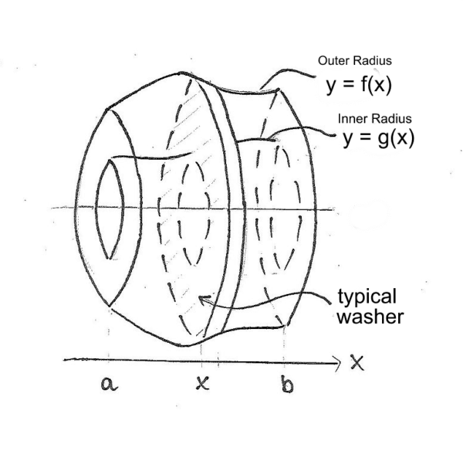

* Here you would integrate with respect to x as it is being rotated around the x axis.
* Formula:



Different Axes (Hardest thing for me)

* You cannot just integrate to whichever variable you want

|  |  |
| --- | --- |
| Axis of Rotation | Integrate with respect to |
| Vertical : x = n | Y (Everything is turned on its side compared to the previous problems, we have to make sure both boundary functions are solved for X). **Say X = n is the axis of rotation, solve for X.** |
| Horizontal : y =n | X ( Everything is turned on its side compared to the previous problems, we have to make sure both boundary functions are solved for Y). **Say Y = n is the axis of rotation, solve for Y.** |

Visual example:

* The axis of rotation is a vertical line x = -1 (rather than the horizontal x-axis). It hits the x-value.

